Complete.
head abdomen six thorax

Insects body is divided into __________________, _____________________ and
__________________________.

Insects have ______________ legs.

Match
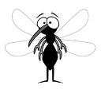
1. ______ bee


2. ______ ant

3. ______ mosquito
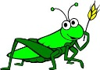
4. ______ butterfly

5. ______ beettle

6. ______ dragonfly

7. ______ grasshopper
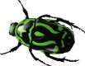
8. ______ centipede
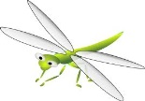
9. ______ ladybug
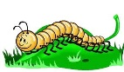
10. ______ fly

